🏡 USA Real Estate Market Analysis

1. Project Overview
Objective
The objective of this project is to analyze residential real estate listings across the United States to uncover pricing patterns, geographic trends, property characteristics, and market structure.
The dashboard is designed to support data-driven decision-making for stakeholders such as investors, analysts, and real estate professionals.
Key Business Questions
- How are listings distributed geographically across the U.S.?
- What cities command the highest median prices and price per square foot?
- How does house size relate to listing price?
- Which property configurations (beds/baths) are most valuable?
- What proportion of the market consists of standard vs luxury listings?

2. Dataset Description
Data Source
Public real estate listings dataset containing residential properties across the United States.
Key Columns Used
- price, price_per_sqft
- house_size (sq ft), bed, bath
- city, state, zip_code
- status (for_sale, ready_to_build)
Data Volume
- Total listings: ~683,000
- Standard listings: 672,636
- Luxury / extreme listings: 10,350

3. Data Cleaning & Preparation in Jupyter Notebook (python)
Steps Performed
- Loading data: Imported the dataset using pandas
- Initial exploration: Used df.shape to check the size of dataset and df.head() to look at the first rows (the sample subset of dataset).
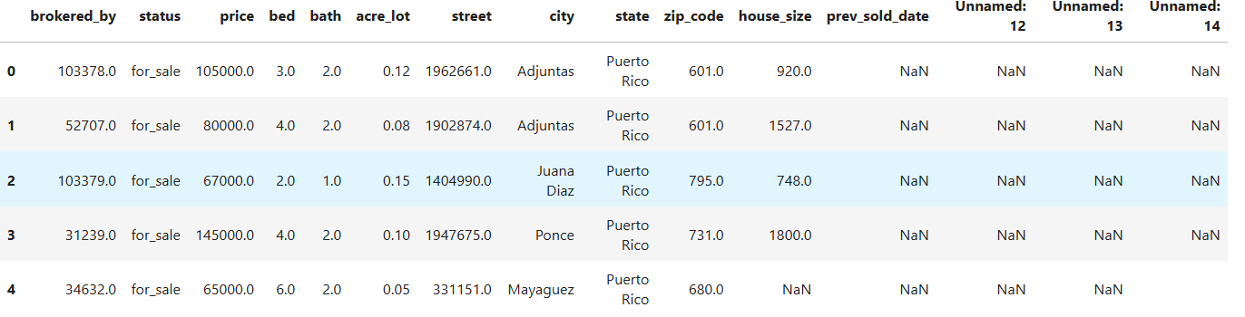

- Column Standardization: Standardize column names first using
df.columns.str.strip().str.lower() .str.replace(' ', '_').str.replace('-', '_') for readability and documentaion
- Drop the invalid columns with df.drop(['unnamed:_12', 'unnamed:_13', 'unnamed:_14'], axis=1, inplace=True)
- Check the duplicates and data types using df.duplicated().sum() and df.dtypes
- Strip the data to avoid leading and tailing space issue; and standardize the datatype to consolidate data accuracy
- Missing Data Handling: check missing values with df.info(). Drop null values in critical columns (price, state, status) and impute nulls in (bed, bath) with median and in city column with unknown.
- Handling Invalid Values: Check the invalid values in key numerical columns and assigned as missing values pd.NA. Drop again the nulls in price and house size. Valiate null values with df.isna().mean().sort_values(ascending=False) for missing ratio and df.isna().sum() for number of missing values for each column
- Feature Engineering:
Created price_per_sqft by dividing price by house_size
Created prev_sold_year from prev_sold_date
- Validate Data: Checking distinct states. Sorted the data according to "prev_sold_year" and "prev_sold_date".
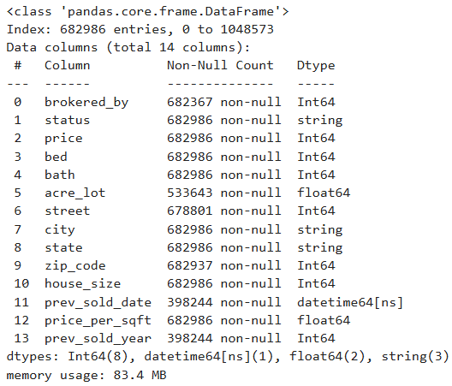
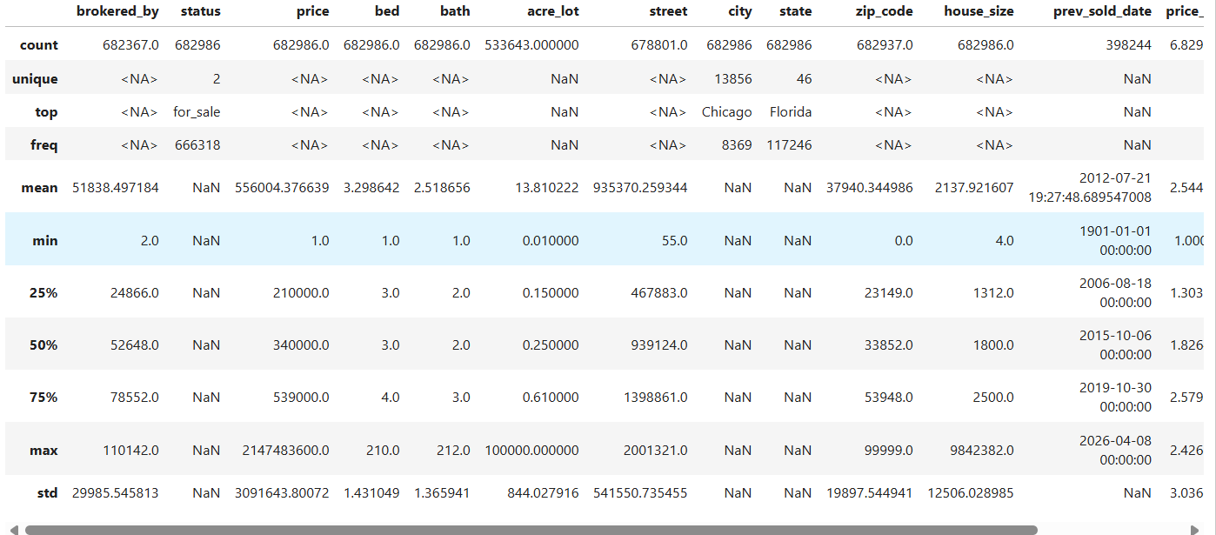
- Exporting data: Used the df.to_csv().

4. Data Analysis and Visualization in Power BI
Outlier Handling Strategy
- Identified and flagged extreme listings for transparency
- Extreme values were not removed
- Instead, they were flagged and separated to preserve market integrity and avoid misleading medians
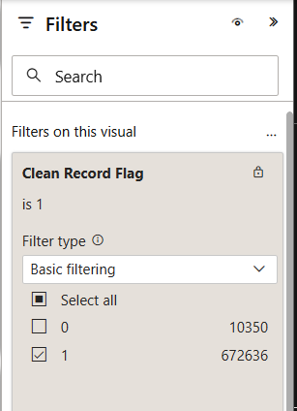
DAX
- New Measure:
Luxury or Extreme Listings
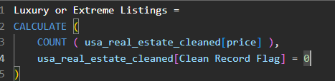

Standard Listings

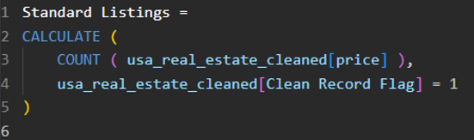

Total Listing
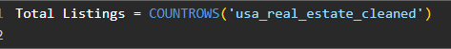

- New Column:
Acre Lot Outlier Flag
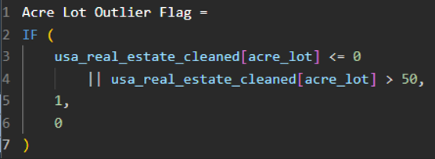

Bed Bath Outlier Flag
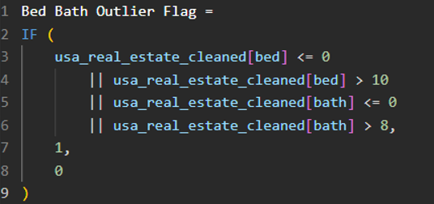

Clean Record Flag
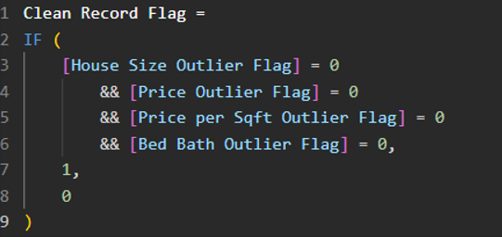

House Size Outlier Flag
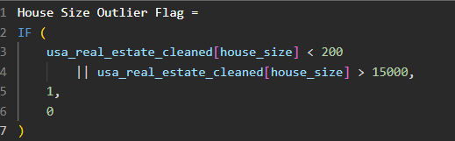

Price Outlier Flag
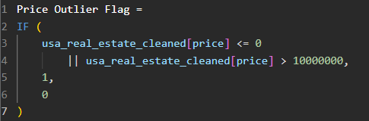

Price per Sqft Outlier Flag
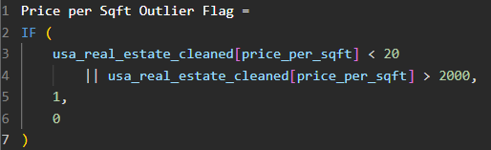

Bed Category
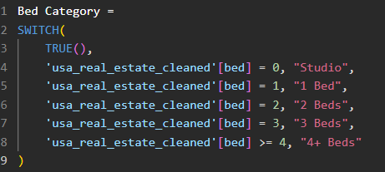

Key Metrics (KPIs)
The dashboard highlights the following KPIs at the top level:
- Total Listings: 683K
- Median Price: $340K
- Median Price per Sq Ft: $182.64
- Median House Size: 1,800 sq ft
- Median Bedrooms: 3
- Median Bathrooms: 2
- Data Coverage and Transparency (Standard Listings: 672636, Luxury or Extreme Listings: 10350)
These KPIs provide a quick snapshot of the U.S. residential market.

5. Dashboard Design & Visuals
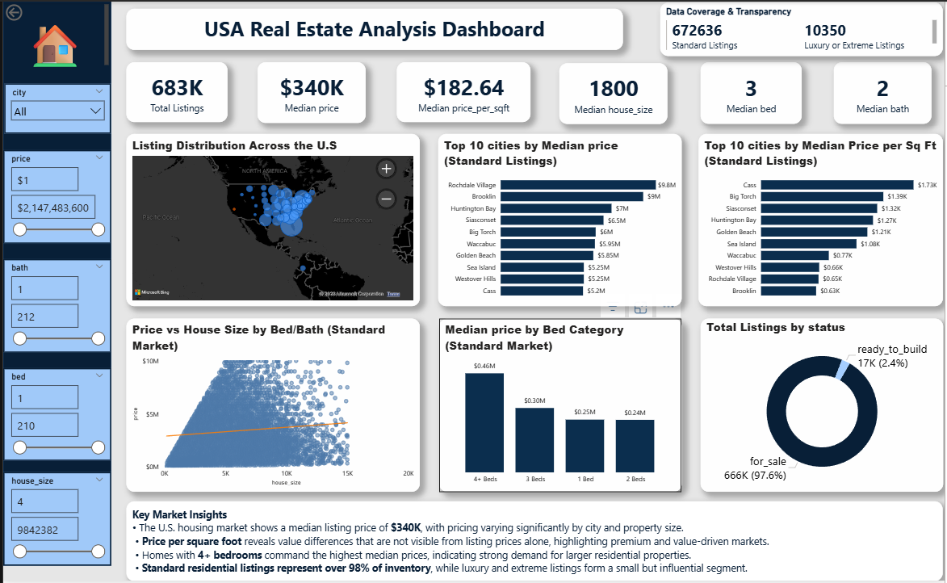
Visual Components Used
Visual | Purpose
KPI Cards | High-level market summary
Map (Bubble) | Geographic distribution of listings
Bar Charts | Top 10 cities by median price and price per sq ft
Scatter Plot + Trendline | Relationship between house size and price
Column Chart | Price comparison by bed category
Donut Chart | Listing status distribution
Slicers | Interactive filtering by city, price, beds, baths and house size

6. Key Insights & Findings
Market Overview
- The U.S. housing market shows a median listing price of $340K, with significant variation by city and property size.
- Listings are densely concentrated in major metropolitan regions, indicating strong urban housing supply.
Pricing Dynamics
- Price per square foot reveals value differences not visible in total prices alone, highlighting premium and value-driven markets.
- Larger homes generally command higher prices, but the trend line shows diminishing returns as size increases.
Property Configuration
- Homes with 4+ bedrooms achieve the highest median prices, indicating strong demand for larger residential properties.
- Smaller homes remain competitive in price-per-square-foot terms.
Market Structure
- Standard residential listings account for over 97% of total inventory.
- Luxury and extreme listings form a small but influential segment, justifying separate treatment in analysis.

7. Stakeholder Value
For Investors
- Identify cities with high price-per-square-foot potential
- Understand demand patterns by house size and configuration
For Analysts
- Clear segmentation between standard and extreme listings
- Transparent handling of outliers
For Business Users
- One-page executive dashboard for fast decision-making
- Interactive filters to explore specific market segments

8. Tools & Technologies
- Power BI – Data modeling, DAX, and visualization
- DAX – KPI calculations and filtering logic
- Excel / CSV – Data preprocessing
- Bing Maps – Geographic visualization

9. Limitations & Assumptions
- Dataset represents listings, not final transaction prices
- Some regions may be overrepresented due to data availability
- Price trends do not account for temporal changes (time-series analysis not included)

10. Conclusion
This project demonstrates how data visualization and analytics can uncover meaningful insights from large-scale real estate data.
By combining KPIs, geographic analysis, and price-size relationships, the dashboard provides a clear, actionable view of the U.S. housing market while maintaining transparency and analytical rigor.

11. Future Enhancements
- Add time-based trend analysis
- Include mortgage rate or economic indicators
- Predictive modeling for price estimation
- Separate dashboards for luxury vs standard markets

